Update Work Email & Phone

How to Update Work Phone Number
- On your home page, click on your picture in the upper right hand corner.
- Click on your name where it says View Profile.
- Under your picture there will be a list of tabs you can view, click on the Contact tab.
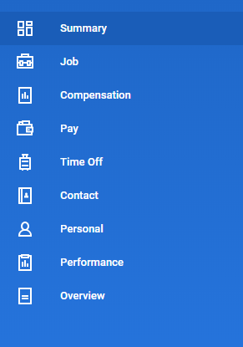
- From there, click on the Edit button.
- Scroll down to where it says Work Contact Information and click on the pencil icon under Primary Phone.
  - Phone Device: Landline
  - Country Phone Code: United States of America
  - Area Code: 808
  - Phone Number: Your office phone number
  - Phone Extension: You do not need to put your extension number
  - Under Details, select Public as the Visibility
  - When you’re done, it should look like the example below (pg. 2)
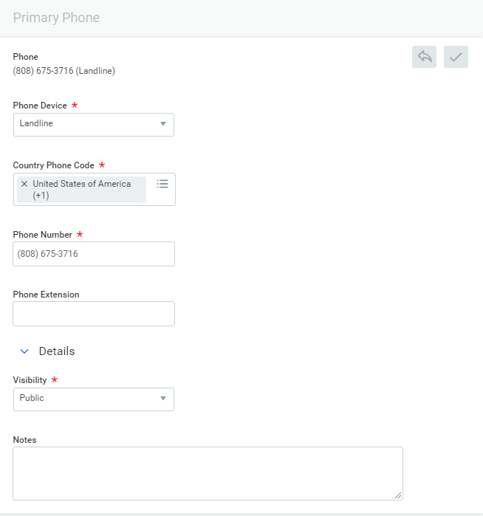

How to Update Work Email
- Click on the pencil icon under Primary Email.
- Enter your work email address (should end with @byuh.edu).
- Under Details, select Public as the Visibility.
- When you’re done, it should look like the example below.

